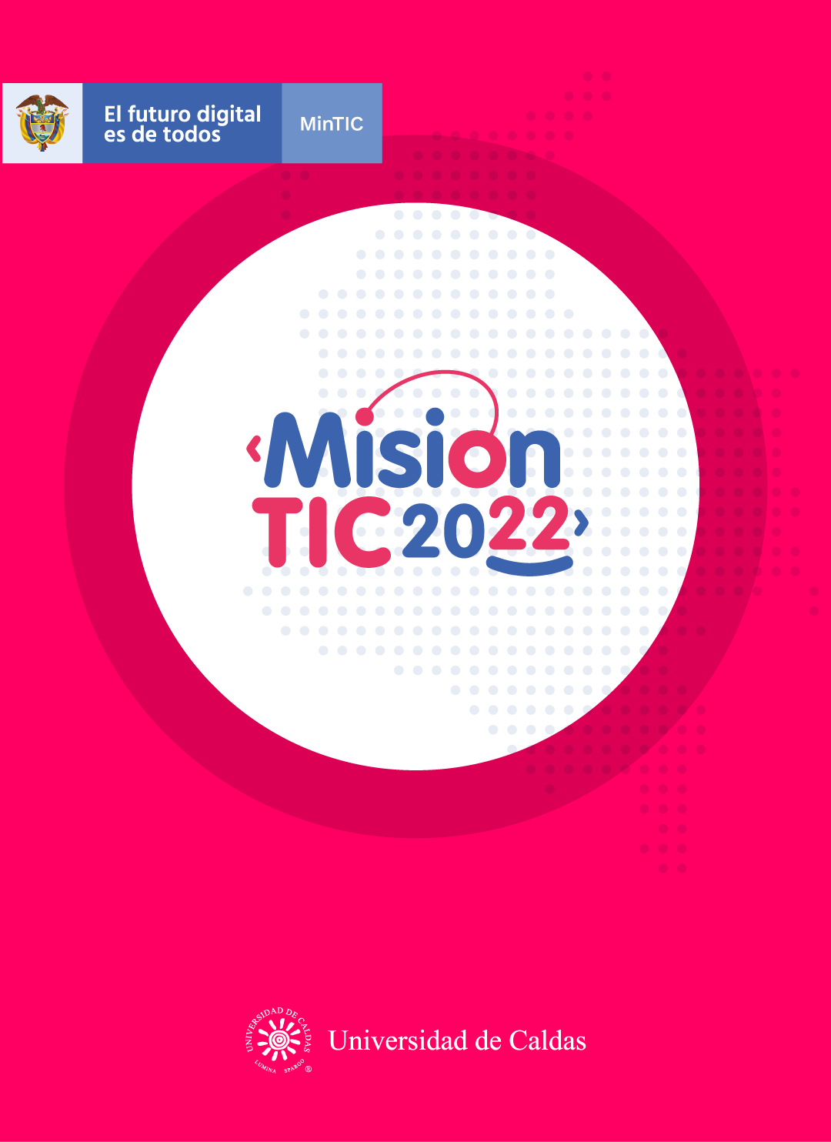

**OBJECT-ORIENTED PARADIGM: INTRODUCTION**

**Object-Oriented Paradigm: introduction**

**Worksheet 2.1**

**Approach :** acercarse,aproximarse,enfoque,aproximación.

**Subroutines:** tarea secundarias,subrutinas.

**Way:**manera,camino

**Goal:**meta,objetivo

**Encapsulates:**encapsular,encerrar

**Make sense:** tener sentido

**Card:** tarjeta

**Match the vocabulary word with the synonym.**

|  |  |
| --- | --- |
| **Vocabulary Word** | **Synonym** |
| 1. Approach | Form ( 3 ) |
| 1. Subroutines | Objective ( 4 ) |
| 1. Way | Become clear ( 6 ) |
| 1. Goal | Ticket ( 7 ) |
| 1. Encapsulates | Habits ( 2 ) |
| 1. Make sense | Enclose ( 5 ) |
| 1. Card | Advance ( 1 ) |

**Worksheet 2.2**

**Match the words with its definitions**

* **Approach:**
* **Subroutines:**
* **Way:**
* **Goal:**
* **Encapsulates:**
* **Make sense:**
* **Card:**

**_____subroutines__________ : a set of instructions designed to perform a frequently used operation within a program.**

**___way____________ : a method, style, or manner of doing something; an optional or alternative form of action.**

**___card____________ : a piece of thick paper, in particular one used for writing or printing on.**

**______goal_________ : the object of a person's ambition or effort; an aim or desired result.**

**_____encapsulates__________ : express the essential features of something.**

**________make sense_______ : be intelligible, justifiable, or practicable.**

**_____approach__________ : a way of dealing with a situation or problem / come near or nearer to (someone or something) in distance or time.**

**Worksheet 2.3**

**Read the following text and use all the word features to annotate the text**

**Object-Oriented Paradigm: introduction**

The term *programming paradigm* is used to specify a general **approach** to writing program code.

If you program using the procedural paradigm, you focus on dividing your program into **subroutines**. The object-oriented programming paradigm (OOP) introduces a fundamentally different **approach** to program design. When you take the object-oriented **approach**, you will identify the objects that make up the system and the **way** they interact with each other.

Many programming languages support multiple paradigms. Python, which is a popular general-purpose programming language, permits you to code using procedural, object-oriented, or functional techniques. Java, another popular language, is exclusively object-oriented.

**The object-oriented approach**

The object-oriented **approach** focuses on the objects that make up the system.

An object is anything that we can name and describe. Objects are 'things' that we want to model in our programs and so the **goal** of an object-oriented program is to represent the real world in code. If you consider the example of a school, the objects would be things like students, teachers, classrooms, and computers. Objects can also be less concrete things, such as lessons, library loans, and exam entries.

The term 'object' in object-oriented programming represents a specific way of organizing code, and it can be defined, technically, as 'an entity that **encapsulates** both data and behavior'. This means that all of the data and all of the procedures/functions of a system belong to one or more objects. Objects in object-oriented programming collaborate with each other, by sending and receiving messages.

If you are a beginning programmer who has experience only with the procedural paradigm, OOP can seem difficult. However, it is just a different **approach**, and one that can really **make sense**. In the next three classes, you will learn about many concepts, using the example of a **card** game.

**Comparing object-oriented and procedural approaches**

It is important to remember that both procedural and object-oriented programming paradigms support different ways of solving the same problem.

In the procedural paradigm, the problem is divided into smaller parts called procedures (or functions), and systems are built by combining procedures. These procedures share data by passing data between them or through global variables.

In the object-oriented paradigm, the problem is divided into smaller parts called objects, and systems are built around objects. Objects are representations of things that exist in the real world that we wish to model in a computer system. Objects do not share data.

**Worksheet 2.4**

**Wrap –Up**

**Make corrections in the false statements in order to make them valid.**

1. If you program using object-oriented paradigm, you divide your program into subroutines.

If you program using objetct-oriented paradigm, you divide your program into objects

1. If you program with Python, you can use only object-oriented paradigm.

If you program with Python, you can use using procedural, object-oriented, or functional

1. “Objects” in object-oriented paradigm are abstract things from the real world.

“Objects” in object-oriented paradigm are representations thins from the real world.

1. Objects do not share data and do not collaborate with each other.

Objects do not share data and do collaborate with each other

1. Object-oriented approach is more difficult than procedural approach.

Object-oriented approach is really make sense than procedural approach

**Worksheet 2.5**

**Ask yourself the following questions.**

1. Entiendo qué es Object - Oriented Paradigm.

**Sí No Quizás**

1. Entiendo en qué consiste la estrategia de **Annotation**.

**Sí No Quizás**

1. Usar la estrategia **Annotation** me ayuda a entender mejor el texto.

**Sí No Quizás**

1. Cuando leí el texto de esta clase, utilicé las siguientes opciones de **Annotation**: (marque todas las que aplican).

* + ( x ) Usar colores para resaltar partes difíciles
  + (x ) Usar colores para resaltar ideas principales
  + ( ) Usar diferentes colores
  + ( ) Escribir comentarios al texto
  + ( x ) Escribir preguntas
  + ( x ) Hacer resumen de una parte difícil
  + ( ) Agregar información
  + ( ) Otro: